Week 3-3:

--Practice Session- Coding

ROLL NO.:240801175

Name: Levin Prince L

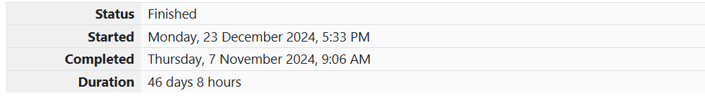

Q1) Some data sets specify dates using the year and day of year rather than the year, month,

and day of month. The day of year (DOY) is the sequential day number starting with day 1

on January 1st.

There are two calendars - one for normal years with 365 days, and one for leap years with

366 days. Leap years are divisible by 4. Centuries, like 1900, are not leap years unless

they are divisible by 400. So, 2000 was a leap year.

To find the day of year number for a standard date, scan down the Jan column to find the

day of month, then scan across to the appropriate month column and read the day of year

number. Reverse the process to find the standard date for a given day of year.

Write a program to print the Day of Year of a given date, month and year.

Sample Input 1

18

6

2020

Sample Output 1

170

Code:

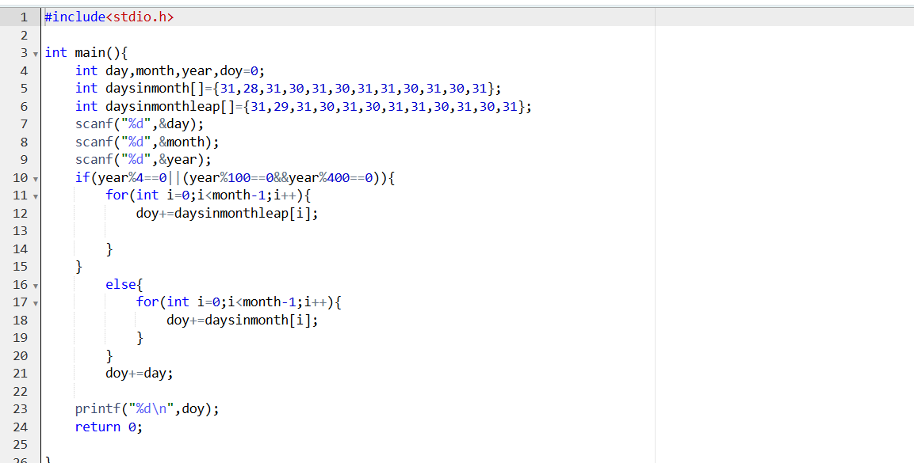

Output:

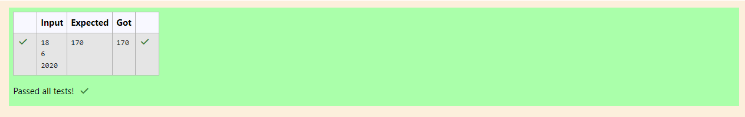

Q2) Suppandi is trying to take part in the local village math quiz. In the first round, he is asked

about shapes and areas. Suppandi, is confused, he was never any good at math. And also,

he is bad at remembering the names of shapes. Instead, you will be helping him calculate

the area of shapes.

• When he says rectangle, he is actually referring to a square.

• When he says square, he is actually referring to a triangle.

• When he says triangle, he is referring to a rectangle

• And when he is confused, he just says something random. At this point, all you can

do is say 0.

Help Suppandi by printing the correct answer in an integer.

Input Format

• Name of shape (always in upper case R --> Rectangle, S --> Square, T --> Triangle)

• Length of 1 side

• Length of other side

Note: In case of triangle, you can consider the sides as height and length of base

Output Format

• Print the area of the shape.

Sample Input 1

T

10

20

Sample Output 1

200

Code:

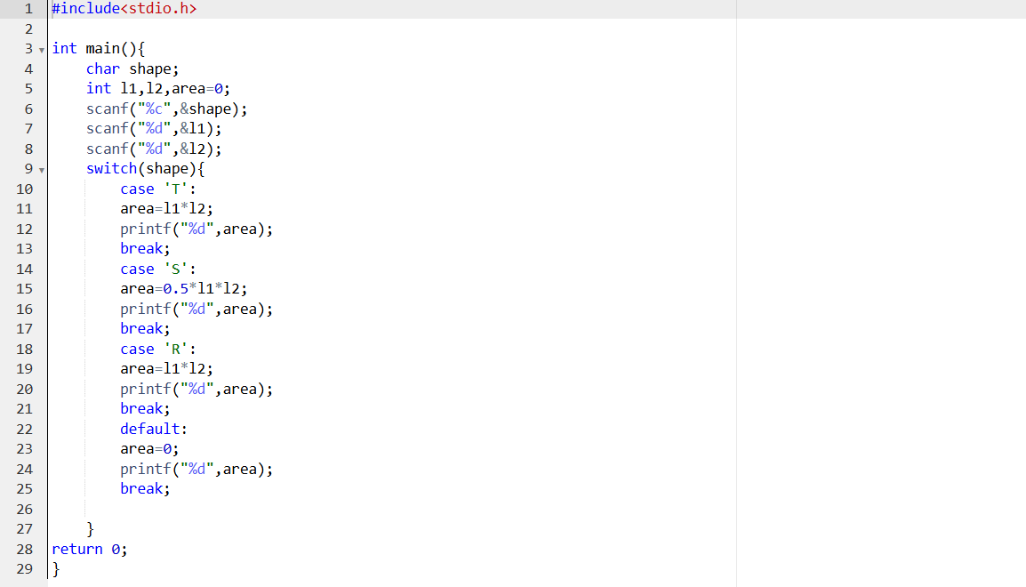

Output:

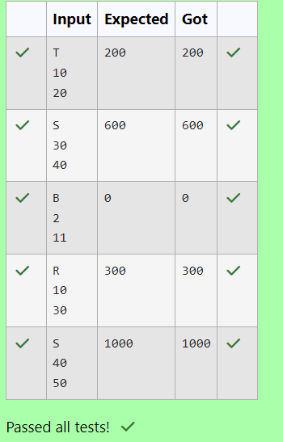

Q3) Superman is planning a journey to his home planet. It is very important for him to know

which day he arrives there. They don't follow the 7-day week like us. Instead, they follow

a 10-day week with the following days:

Day Number Name of Day

1 Sunday

2 Monday

3 Tuesday

4 Wednesday

5 Thursday

6 Friday

7 Saturday

8 Kryptonday

9 Coluday

10 Daxamday

Here are the rules of the calendar:

• The calendar starts with Sunday always.

• It has only 296 days. After the 296th day, it goes back to Sunday.

You begin your journey on a Sunday and will reach after n. You have to tell on which day

you will arrive when you reach there.

Input format:

• Contain a number n (0 < n)

Output format:

Print the name of the day you are arriving on

Sample Input

7

Sample Output

Kryptonday

Sample Input

1

Sample Output

Monday

Code:

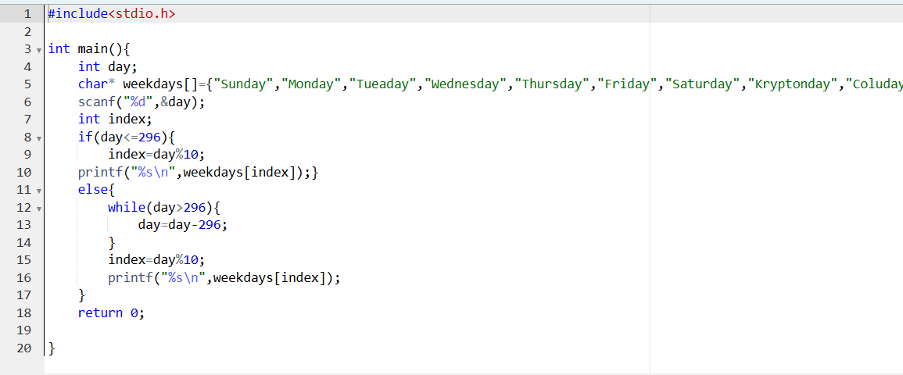

Output:

